Prune Post Edit History
If you wish to prune the Post Edit History for one or more forums, go to Threads and Posts > Prune Post Edit History You will be presented with the options for pruning this.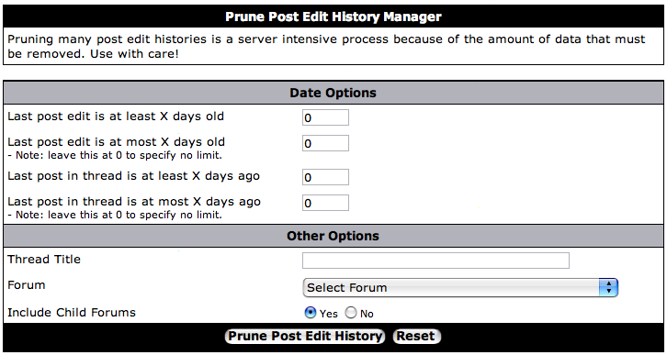
Once you have completed the options and clicked [Prune Post Edit History] you will then be told the number of posts with edit histories which have been selected
Clicking [Prune All Post Edit Histories] will remove all post edit histories for all selected posts.
Warning:
You may not undo a prune. Make sure you want to do this!

